Children’s Book Council of Australia (Queensland Branch)
ABN 84 696 354 454 qld@cbca.org.au
c/- Queensland Writers Centre PO Box 3488 SOUTH BRISBANE QLD 4101

2021 Membership Application and TAX INVOICE – 2021MBR

Yearly CBCA (Qld) Membership 1st Jan – 31st Dec, 2021

(Please complete and email application to qld@cbca.org.au – or complete ONLINE at our website https://qld.cbca.org.au/membership via link to trybooking )

Date:

Name:

Postal Address:

Type of Membership: Personal $45.00
Corporate/School $65.00
Concessional $25.00
Author / Illustrator $25.00

Contact Details – receipt, newsletters, correspondence

Name:

Email:

2nd Name: [Corporate only]

Email:

Payment method (please indicate)

Direct Deposit of $_______ to CBCA Qld Branch:
NAB, Albert Street, Brisbane BSB 084-034 Account: 508 433 755.

Payment by Credit Card (please complete details below)

Name on Card:

Card Number: / / /

Expiry Date: Amt: $

Signature:

Membership Benefits

Free entry to Readers Cup Regional Competition (Corporate only)

Discounted entry to CBCA Qld Branch events (2 delegates for Corporate)

Discounts at various independent bookshops (see website for details)

Discount on Book Week Merchandise purchases

Supporting the children’s choice awards – BILBY (Books I Love Best Yearly)

Supporting the Readers Cup which in 2019 had over 750 teams competing – that is over 14000 books being read by our young people.

Supporting community projects (projects included building collections for Save the Children Australia, Ronald McDonald House, Hummingbird Hospice)

Supporting events for adults and children around Children’s Book Week ( Judges Talk, Childrens’ Day at State Library, Panel Author talks)

Monthly e-newsletter of happenings in children’s’ literature
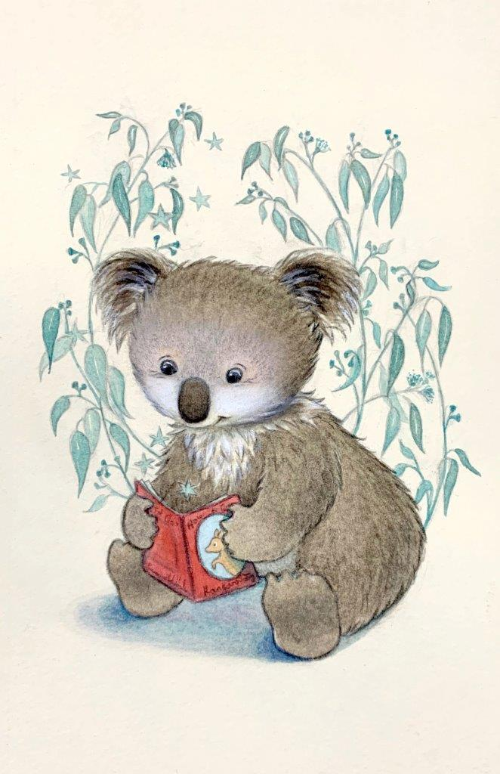

2020 Membership card designed by Emma Middleton

