Children’s Book Council of Australia (Queensland Branch)
ABN 84 696 354 454 c/- Queensland Writers Centre PO Box 3488 SOUTH BRISBANE QLD 4101 qld@cbca.org.au

2018 Personal Membership Application and Tax Invoice

Yearly CBCA (Qld) Corporate Membership 1st Jan – 31st Dec, 2018 $45.00

(Please complete and email application to qld@cbca.org.au -
form also available from our website cbcaqld.org to complete & return online)

Date:

Name:

Postal Address:

Contact Details – receipt, newsletters, correspondence

Email:

Payment method (please indicate)

Direct Deposit of $45.00 to CBCA Qld Branch: NAB, Albert Street, Brisbane BSB 084-034 Account: 508 433 755. Record your name in bank transfer

Payment by Credit Card (please complete details below)

Name on Card:

Card Number: / / /

Expiry Date: Amt: $45.00

Signature:

Cheque – please post to above address (allow up to 4 weeks for up to processing if paying by cheque)

Personal Membership Benefits

Discounted entry to CBCA Qld Branch events

Discounts at various independent bookshops (see website for details)

Supporting Readers Cup – Qld wide competition

Supporting the children’s choice awards – BILBY (Books I Love Best Yearly)

Supporting community projects (eg 2017 projects included building collections for Save the Children Qld)

Supporting events for adults and children around Children’s Book Week (eg 2017 Judges Talk)

Monthly newsletter of happenings in children’s’ literature

Author Talks

Discount on Book Week Merchandise purchases

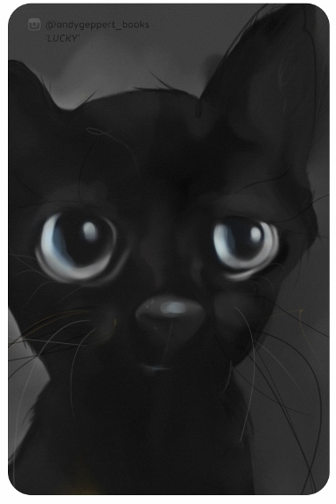
Illustration for Membership 2018 Card (Andy Geppart)

