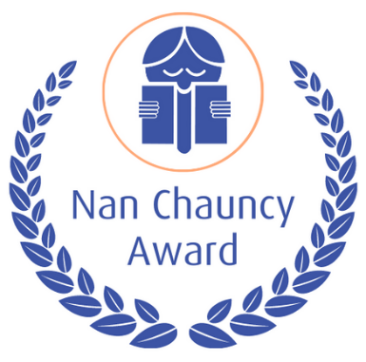

THE NAN CHAUNCY AWARD- 2023

Named after the noted Tasmanian author of children’s books, the Nan Chauncy Award has been created to honour individuals who have made an outstanding contribution to the field of Australian children’s literature. The spirit of the Award is to recognize advocacy, mentoring and volunteer work beyond paid roles and professional responsibilities. The Award is an opportunity to recognize an individual or partnership whose dedicated work in advocacy and promotion of literature and literacy might otherwise not be publicly celebrated.

From 1983 to 1998, the Nan Chauncy Award was presented every five years. Since 2000, the CBCA Nan Chauncy Award has been made biennially, according to the Roster outlined in Appendix A. A list of past recipients can be found on the CBCA website: http://cbca.org.au/other-cbca-awards.

Administration

The CBCA Nan Chauncy Award is administered by the CBCA National Board who may delegate responsibility to a Coordinator.

Eligibility

  - The recipient or recipients must be Australian citizens, no matter where residing, or have been residents in Australia for at least five years. In the case of a person who is not an Australian citizen, eligibility shall cease at the time when the person ceases to be a resident of Australia.

  - The Award can be given to an individual recipient or collaborative partnership who have made an outstanding contribution, over a period of years, to the field of Australian children’s literature. Such recipients could include an editor, publisher, volunteer at branch or national level, teacher, teacher-librarian, bookseller, lecturer, researcher, author, illustrator, etc. The Award is an opportunity to recognize an individual or collaborative partnership whose dedicated work in advocacy and promotion of literature and literacy might otherwise not be publicly celebrated.

  - Nominees must be living at the time nominations close (28 April in the year of the Award).

  - A person can receive the Award only once.

  - There can be only one recipient (an individual or collaborative partnership) of the Award in any one year.

  - Unsuccessful nominees may be nominated for subsequent Awards.

  - The recipient need not be a member of a CBCA Branch.

Form of the Award

The Award shall consist of two parts:
- A citation to be written by the Nan Chauncy Selection Panel
- An appropriate commemorative gift to be commissioned by the National Board.

Note: It has been customary to present an item made of Tasmanian timber.

Selection Process

  - There are three Selection Panel members. They must be financial or life members of a Branch of the CBCA.

  - Panel members and the Coordinator shall be appointed by the CBCA National Board.

  - Should any member of the Nan Chauncy Selection Panel be nominated for the Award or be unable to participate in the process for any reason, s/he will immediately withdraw, inform the Coordinator and be replaced by a representative from, or appointee of, the National Board.

  - The Panel members exchange views by email and online meetings with a final online meeting convened at which they select the Award recipient and arrange to write the citation.

  - The Panel’s processes and meetings are to be determined and chaired by the Coordinator, who does not have a vote in any Panel decision.

  - Once the Panel has reached a decision the Coordinator is to inform the National Chair in writing, with a copy of the citation to follow.

  - The Panel has the right to make no award.

The Panel, in liaison with the Coordinator, prepares the Citation, drawing on material contained in the nomination documentation. The Citation stands as an historical record of the Award. It is a formal, single page document that highlights the contribution of the recipient (individual or collaborative partnership)
  - The Panel members are to write, or to commission, a substantial article on the recipient to be published in Reading Time.

  - The written article shall also be sent out to all print media and social media contacts to maximise publicity. (see also 6.e.)

Nominations

  - The Coordinator is to call for nominations for the Award at the beginning year of the Award. Notices are to be placed in Reading Time and other appropriate publications and on social media platforms of the CBCA National and CBCA Branches

  - Financial and Life Members of Branches of the CBCA may nominate eligible people.

  - Nominations are to be accompanied by 2 or 3 testimonials of between 800—1000 words and can be linked to appropriate social media.

  - Testimonials must be completed using the official form in Appendix D. This is available from the CBCA Website.

  - Nominations must be received by 28 April in the year of the Award. Late nominations will not be accepted.

  - Receipt of the nomination will be acknowledged by the Coordinator via return email

  - In the event that more than one nomination is received from a Branch, the judges will decide which nomination to use in the selection process

  - The Coordinator shall forward copies of the nominations to each Panel member by 1 May in the year of the award.

Announcement and Presentation

  - After the Selection Panel has reached a decision at the final meeting, the Coordinator immediately informs the National Chair.

  - The National Chair informs the selected recipient.

  - The Award is to be publicly announced at an appropriate time to be determined by the National Board. Where possible the recipient should be informed before the announcement.

  - The Award is to be presented at the same time as the CBCA Book of the Year Awards, or else at an appropriate time and venue to be determined by the National Board.

  - Information about the Award and a copy of the citation are to be sent to Branch Presidents and the media.

Confidentiality

  - The list of nominations is confidential. Only the National Chair, Coordinator and the Selection Panel are to receive it.

  - The name of the recipient is to be confidential until cleared for public release by the National Chair. However, the recipient and the person commissioned to write the article for Reading Time are to be informed.

  - All nominations should be acknowledged as received and all nominators informed when their nominee is unsuccessful. The award recipient will not be divulged.

  - Process after the Award:
All nominations and notes are to be destroyed after the Selection Panel’s meeting, with the exception of the following items which are to be sent to the National CBCA Archives:
    - Information on the three panel members.
    - A copy of the citation.
    - The nomination form of the recipient and accompanying Statement including all Testimonials

Financial Arrangements

  - Branches shall pay a levy of $50 every two years to cover the cost of the gift and any judging expenses. (See 4: Selection Process).

  - The National Board shall pay for the recipient to attend the Awards Presentation if necessary.

Appendices A - D

- Roster for Selection of CBCA Nan Chauncy Award Selection Panel

- Call for nominations template for Branch Newsletters

- Advice to Nominators document

- Nomination Form

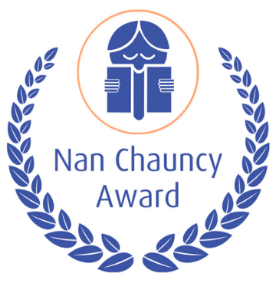

Appendix A

THE NAN CHAUNCY AWARD

Roster for Selection Panel

Year | National | Judge 2 | Judge 3
2021 | NT | VIC | WA
2023 | NSW | TAS | QLD
2025 | ACT | NSW | NT
2027 | WA | QLD | SA
2029 | TAS | NSW | ACT

Appendix B

Example: Call for nominations

CALL FOR NOMINATIONS

THE NAN CHAUNCY AWARD

A BIENNIAL AWARD OF THE CHILDREN’S BOOK COUNCIL OF AUSTRALIA

From the late 1950s until the early 1970s, Nan Chauncy was one of the most esteemed children’s writers in Australia.
She distinguished herself by winning the Australian Children’s Book of the Year three times, had three titles commended in the following seven years and gained international recognition, including receiving a Diploma of Merit in the Hans Christian Andersen Award (Eastman, B. 2000; Lees, S. & Macintyre, P. 1993; Niall, B. 1984).

In recognition of the writer’s significance in the history of literature for young Australians, CBCA instituted the Nan Chauncy Award in 1983. The Award is currently conferred biennially.

The CBCA Nan Chauncy Award has been created to honour a person or collaborative partnership who have made an outstanding contribution to the field of Australian Children’s Literature over a period of years. Such a person or collaborative partnership could be an editor, publisher, teacher, librarian, bookseller, researcher, lecturer, author, illustrator, etc. It is envisaged that the collaborative partnership would be a long-term professional association that is recognized and well known. The purpose of the Award is to recognize an individual or collaborative partnership beyond paid roles, whose passionate advocacy, mentoring and promotion of literature and literacy might otherwise not be publicly celebrated.
The recipient or recipients of the Award must be Australian citizens, no matter where resident, or resident in Australia for at least five years. The recipient need not be a member of a Branch of the Children’s Book Council of Australia.

Financial and Life Members of CBCA may nominate eligible people. All nominations must be on the official form, obtainable from the Children’s Book Council of Australia Branches and the National Board. Nominees must be living at the time nominations close.

Nominations close on April 28^{th,} 2023

Enquiries:
The Coordinator, Nan Chauncy Award Leanne Rands
rands3@bigpond.com
0418551979
Entry forms and advice to nominators are also available from your Branch office, the CBCA National Board
http://cbca.org.au/other-cbca-awards

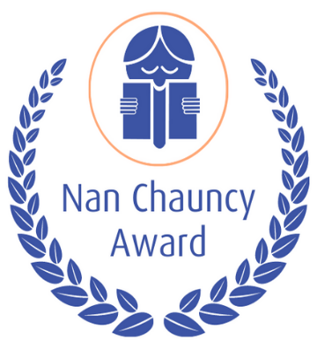

Appendix C

THE NAN CHAUNCY AWARD

ADVICE TO NOMINATORS

The CBCA Nan Chauncy Award has been created to honour a person or collaborative partnership who have made an outstanding contribution to the field of Australian Children’s Literature over a period of years. Such a person or collaborative partnership could be an editor, publisher, teacher, librarian, bookseller, researcher, lecturer, author, illustrator, etc. It is envisaged that the collaborative partnership would be a long-term professional association that is recognized and well known. The Award is an opportunity to recognize an individual or collaborative partnership whose dedicated work in advocacy and promotion of literature and literacy might otherwise not be publicly celebrated.

It is important to realize that nominations can be judged only on the written evidence provided and that the selection panel will decide the winner by comparing the evidence presented in each nomination.

- Nominators should use the word limit allowed to provide detailed evidence to do justice to their nominee or nominees

- Nominators should consult appropriate people, if necessary, in order to give a full account of their nominee or nominee’s achievements. They need to provide all the information they wish to be taken into consideration.

- Material from published sources is not admissible, with the exception of brief quotations. The bulk of the nomination must be in the nominator's own words.

- The 1000 word limit will be strictly adhered to. Any additional material will not be considered by the judges.

- Nominations are to be accompanied by 2 or 3 Testimonials and can include information and links to appropriate social media.

- The closing date for nominations (April 28th) will be strictly observed. Late entries will not be accepted.

SELECTION CRITERIA

In order that the Selection Panel can compare the relative merit of nominated candidates for the Award, nominators should address the following criteria:

  - Nature of the nominees’ contribution to the field of Australian literature for children and young people

  - Period over which the contribution has been made

  - Any exceptional input to the field above and beyond their remunerated role/s

  - Explanation of the impact of the individual on colleagues and the general public

  - Evidence to support the claims made in the nomination

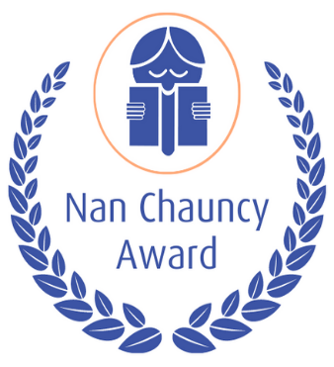

Appendix D

THE NAN CHAUNCY AWARD

Nomination Form 2023

Full Name of Nominee

Home Address

Telephone Home ( ) Work ( )

Email _________________________________________________

Australian Citizen or Australian Resident for years

Name of Nominator

Home Address

Mobile Number _________________________________________________________

Email

NOMINATION

As a financial member or life member of the _________________Branch of the Children’s Book Council of Australia I hereby

nominate _____________________________________________________for the 2023 Nan Chauncy Award.

Signed Date

PLEASE ATTACH A STATEMENT OF NO MORE THAN 1000 WORDS SETTING OUT THE REASONS FOR THIS NOMINATION. IT IS RECOMMENDED THAT THE SHEET ADVICE TO NOMINATORS (Appendix C) BE CONSULTED BEFORE COMPLETING THE NOMINATION.

NOMINATIONS CLOSE APRIL 28TH 2023

EMAIL NOMINATIONS TO:

Nan Chauncy Award Nomination

The Nan Chauncy Award Coordinator
Leanne Rands

rands3@bigpond.com

