2024-25 Book of the Year Judge
Conflict of Interest Declaration
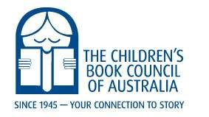

To: National Chair, The Children’s Book Council of Australia Board

I declare that as a Judge of The Children’s Book Council of Australia I have a conflict of interest in the following matter:
(creator, editor or associated with entry in Awards)

I declare that I have a direct or indirect interest in the following advice or report that is to be considered at the following meeting:
(state the subject of the advice/report and meeting details)

Further, I declare that the type of interest that has given rise to the conflict is either:
(place an X in the circle next to the interest/s)

〇 A direct interest (See Definitions in Policy Statement)
〇 An indirect interest due to a close association (e.g. author, illustrator, publisher)
〇 An indirect interest due to a financial interest (e.g. author, illustrator, publisher)
〇 An indirect interest because of conflicting duties (e.g. reviewer)
〇 An indirect interest because of receipt of an applicable gift
〇 Other: (specify nature of interest)

Alternatively, I declare that:

I have no conflict of interest in relation to my duties but that I will lodge a new declaration in the event that I become aware of the conflict of interest during the course of my duties as a member of the Board or if/when a conflict of interest arises during consideration of Board matters.

Further, I declare that I have no conflict of interest that would breach the provisions of the Board’s Code of Conduct.

Name:
Signature:
Date:
CBCA Book of the Year Awards Policy PL-007-06
Last updated August 2020

