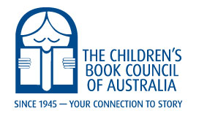

2021-23 Book of the Year Judge
Application Cover page

Personal Details

Name: …………………………………………………………………………………………

Address: ………………………………………………………………………………………

Email: ………………………………………………………………………………….………

Phone: ………………………………… Mobile: ……………………………………………

Branch Membership No: ………………………… Branch: ………………………………

Working with Children Clearance Certificate/Card approved (copy attached)
Category Preference based on your qualifications and experience (1-Most, 5-Least):

- Book of the Year: Older Readers (OR)
- Book of the Year: Younger Readers (YR)
- Book of the Year: Early Childhood (EC)
- Picture Book of the Year (PB) also CBCA Award for New Illustrator (NI)
- Eve Pownall Award (EP)

Have you been a judge for the CBCA Book of Year Awards? YES / NO Year:
Have you been a judge for any other awards? YES / NO. If yes, please give details.

…………………………………………………………………………………………………

