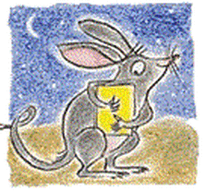
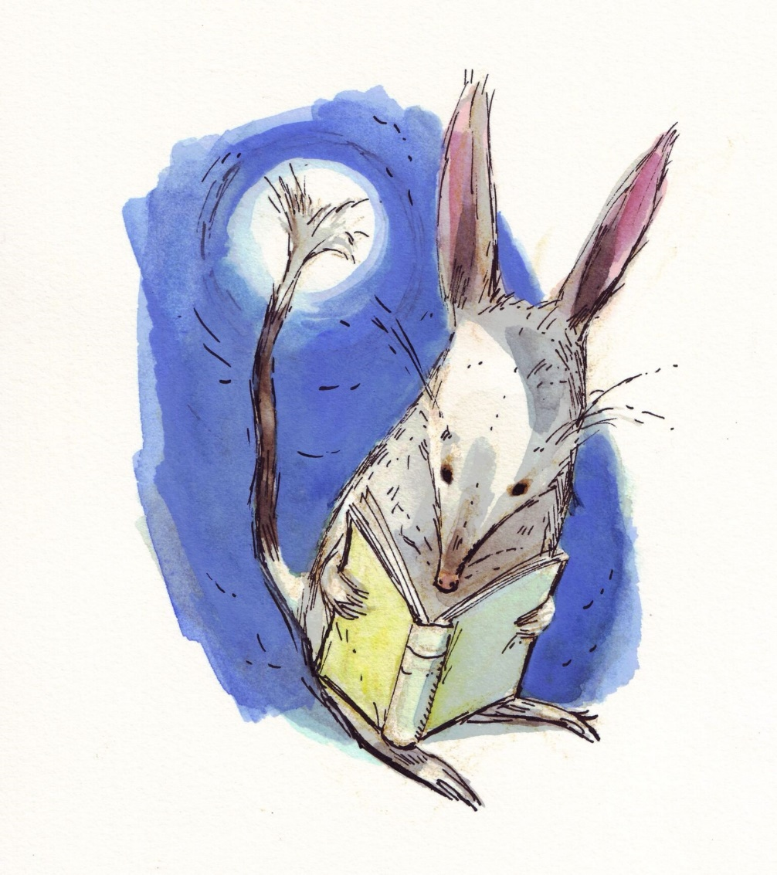
BILBY 2017
BOOKS I LOVE BEST
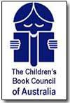
Children’s Choice Award
NOMINATE NOW!
Nominations close 31 March
More information from your teacher or librarian
Email: bilbyqld@cbca.org.au

