Children’s Book Council of Australia (Queensland Branch)
ABN 84 696 354 454 P O Box 828, Spring Hill Qld 4004 qld@cbca.org.au

2017 Concessional Personal Membership Application and Tax Invoice

Yearly CBCA (Qld) Corporate Membership 1st Jan – 31st Dec, 2017 $25.00

(Please complete and email application to qld@cbca.org.au -
form also available from our website cbcaqld.org to complete & return online)

Date:

Name:

Postal Address:

Contact Details – receipt, newsletters, correspondence

Email:

Payment method (please indicate)

Direct Deposit of $40.00 to CBCAQld Branch: NAB, Albert Street, Brisbane BSB 084-034 Account: 508 433 755. Record your name in bank transfer

Payment by Credit Card (please complete details below)

Name on Card:

Card Number: / / /

Expiry Date: Amt: $25.00

Signature:

Cheque – please post to above address (allow up to 4 weeks for up to processing if paying by cheque)

Personal Membership Benefits

Discounted entry to CBCA Qld Branch events

Discounts at various independent bookshops (see website for details)

Supporting the childrens choice awards – BILBY (Books I Love Best Yearly)

Supporting community projects (eg 2016 projects included building collections in Ronald McDonald House and Hummingbird House)

Supporting events for adults and children around Children’s Book Week (eg 2016 Awards Dinner and The Big Draw)

Monthly newsletter of happenings in children’s’ literature

Author Talks

Discount on Book Week Merchandise purchases

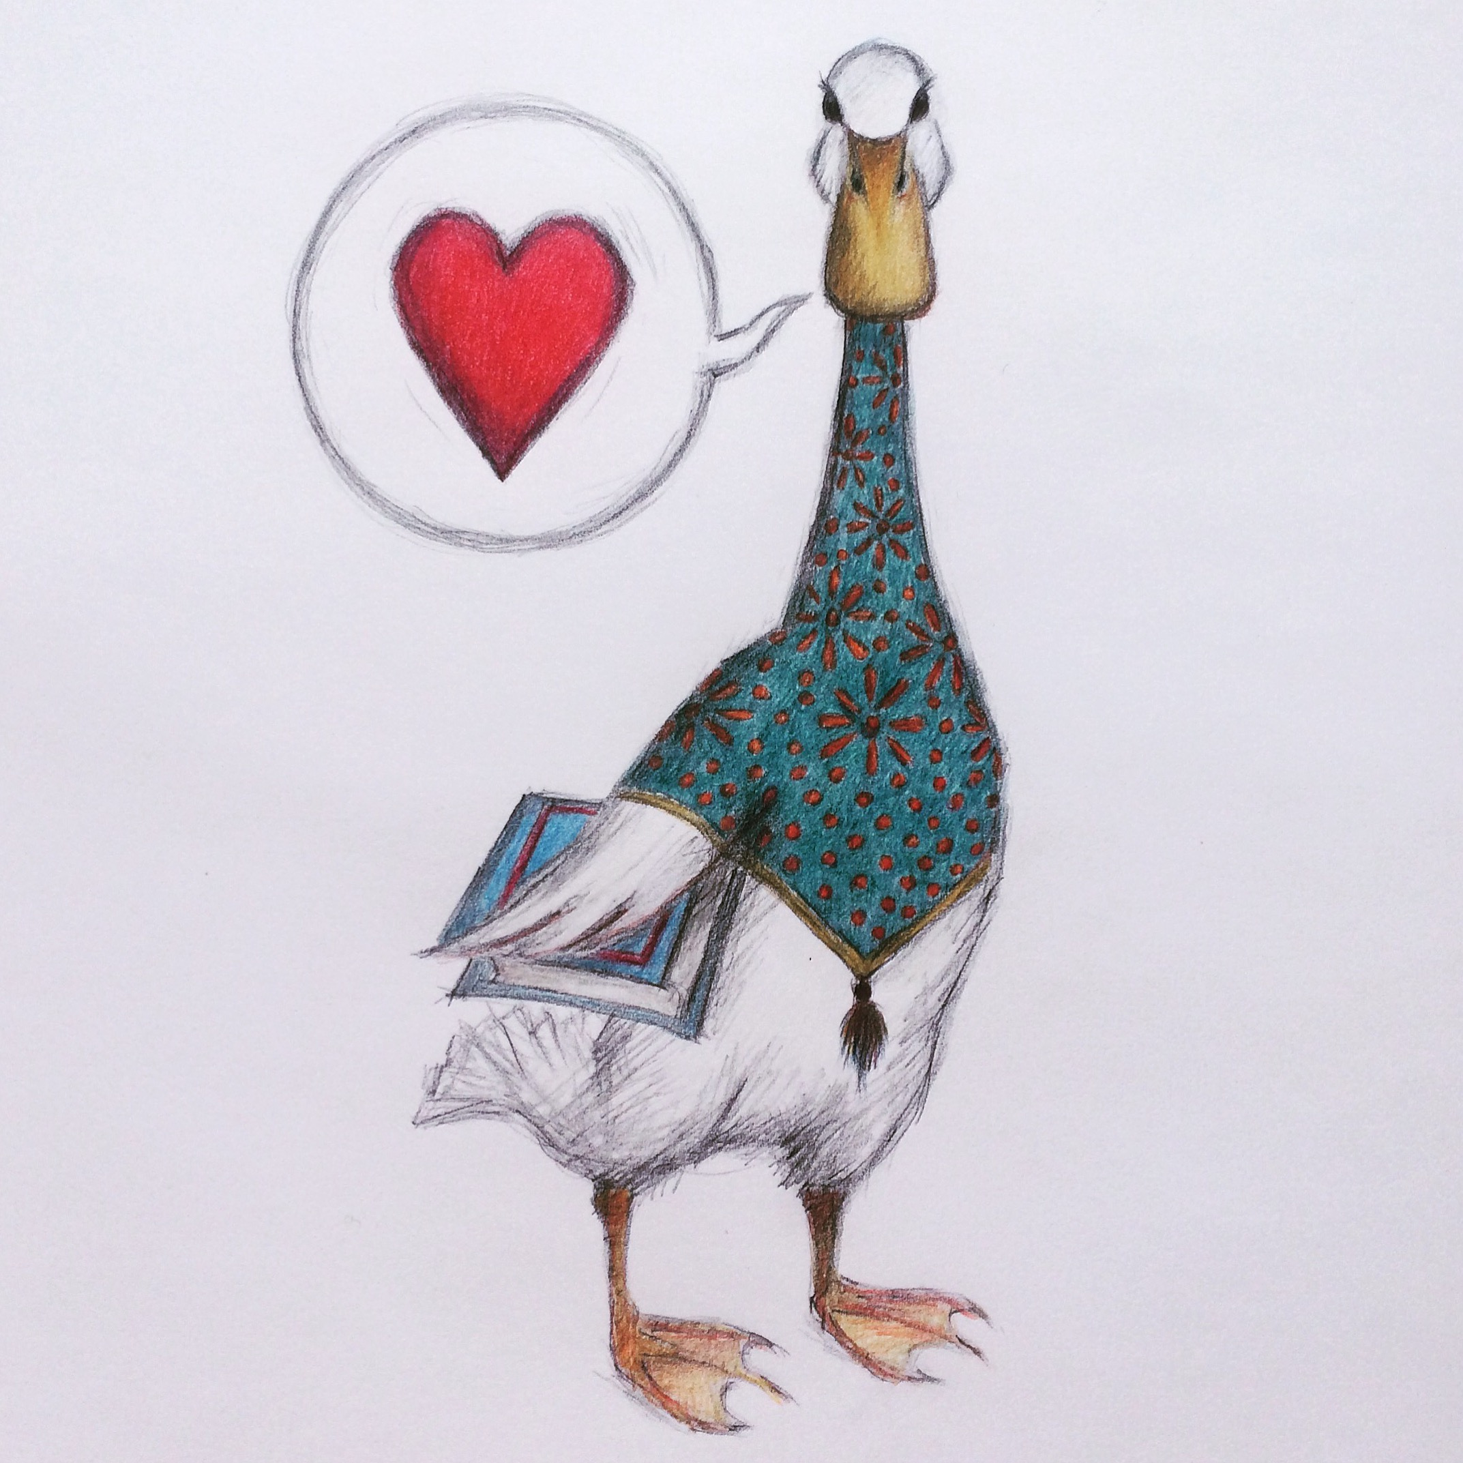
Illustration for Membership 2016 Card (Sue Wright)

